# Contents

Contents 1

Chapter 1: Introduction 3

1.1 Project Overview 3

1.2 Thesis Objectives 3

Chapter 2: Market Analysis 5

2.1 Similar Company Websites 5

2.2 Market Landscape and Trends 7

2.3 Summary 8

Chapter 3: Comparison with Initial Assumptions 9

3.1 Review of Sent Assumptions 9

3.2 Comparison of Assumptions to Market Analysis 9

3.3 Adjustments to Project Scope (if necessary) 10

Chapter 4: Technology Stack and Tools 13

4.1 Programming Language and Framework (Django) 13

4.2 Additional Libraries and Frameworks (if applicable) 13

4.3 Database Selection: SQLite 14

Chapter 5: Design Process 16

5.1 User Interface (UI) Design and Prototyping 16

5.2 Information Architecture and User Flow 16

5.3 UI Design Considerations (Responsiveness, Accessibility) 17

Chapter 6: Website Development 20

6.1 Django Project Structure and Application Design 20

6.2 Key Features and Functionality Development 28

6.3 Integration and Testing 31

Chapter 7: Presentation of the Website 33

7.1 Functionality Demonstration 33

7.2 Design Showcase 38

Chapter 8. Summary and Conclusions 41

8.1 Project Achievements 41

8.2 Key Learnings and Recommendations 41

Glossary 43

References 45

Figure 1. View of mystyle.css 18

Figure 2. File structure with staticfiles 19

Figure 3. View for settings.py 20

Figure 4. General view of the urls.py 21

Figure 5. WSGI.py 21

Figure 6. Templates directory 22

Figure 7. Listings' models.py 22

Figure 8. Listings' views.py 23

Figure 9. Listings urls.py 23

Figure 10. Migrations 24

Figure 11. orders' models.py 24

Figure 12. Orders views.py 25

Figure 13. orders urls.py 25

Figure 14. Orders migrations 25

Figure 15. accounts models.py 26

Figure 16. Different views for accounts 27

Figure 17. urls for the accounts 27

Figure 18. migrations for accounts 27

Figure 19. Listing creates 28

Figure 20Listing deletes 28

Figure 21. Listing update 29

Figure 22. Listings reservations 29

Figure 23. Listing search 29

Figure 24. Options on orders 30

Figure 25.User register and login 30

Figure 26. Account view 31

Figure 27. Account search 31

Figure 28. Sign up 33

Figure 29. Log in 34

Figure 30. Account details 34

Figure 31. New Listings 35

Figure 32. Success 35

Figure 33. Listing details 36

Figure 34. Delete option 36

Figure 35. Lisitng search 37

Figure 36. House reservation 37

Figure 37. Reserved listings 38

Figure 38. Manage orders option for admin 38

Figure 39. Navbar on a telephone 39

Figure 40. base.html 39

# Chapter 1: Introduction

## 1.1 Project Overview

The real estate market has seen a significant shift towards digital platforms, with users increasingly relying on websites to search for properties, manage their accounts, and schedule property tours. This project aims to develop a comprehensive and user-centric real estate website using the Django framework. The website will cater to the needs of users looking to buy, sell, or rent properties by providing a seamless and efficient user experience.

The project encompasses several key features:

* **Property Listings**: A robust database of properties with detailed information, high-quality photos, and virtual tours. Users can search for properties based on various criteria such as location, price, and property type.
* **User Accounts**: Functionality for users to create and manage their accounts. This includes saving searches, receiving notifications, and managing property listings.
* **Order Management**: Tools for scheduling property tours and contacting real estate agents directly through the platform. This feature aims to streamline the process of viewing and purchasing properties.

The project is structured into several Django apps, each responsible for a specific aspect of the website:

* **Accounts**: Manages user accounts, including signup, login, logout, and account management.
* **Listings**: Handles property listings, including creation, updating, deletion, and reservation.
* **Orders**: Manages orders related to property tours and purchases.

The project leverages modern web technologies and best practices in design and usability to create a competitive platform in the real estate market. By focusing on user experience and functionality, the project aims to meet the evolving demands of users in the digital age.

### 1.2 Thesis Objectives

The objectives of this thesis are to analyze the market, compare initial assumptions with market findings, and develop a robust real estate website using Django. The thesis is structured to achieve the following goals:

**Market Analysis and Comparison with Initial Assumptions:**

The first objective of this thesis is to perform a thorough market analysis of existing real estate websites, aiming to understand their features, design trends, and user experiences. This analysis will provide valuable insights into best practices and serve as a guide for the development of the project. The analysis begins by identifying key competitors within the real estate website market. These competitors' websites will be evaluated in terms of their features, design, and usability to understand what makes them successful. This evaluation includes a functionality analysis, where the essential features offered by these competitors are assessed to identify must-have functionalities for our project. Furthermore, current design trends within the real estate website market will be analyzed to inform the design process of our website, ensuring it is modern and user-friendly. A comprehensive user experience (UX) analysis will also be conducted to identify best practices and areas for improvement from competitor websites.

Following this detailed market analysis, the initial assumptions made at the project's inception will be reviewed and compared with the findings from the analysis. This step is crucial for ensuring that the project's direction remains aligned with the current market needs and trends. Revisiting the initial assumptions and hypotheses will provide a foundation for comparison, allowing for a critical assessment of how these assumptions hold up against real-world data. Any discrepancies or new insights will guide necessary adjustments to the project scope. This process ensures that the project remains relevant and competitive, incorporating updated information and best practices identified during the market analysis. By adapting the project scope based on a thorough comparison with market findings, the project will be better positioned to meet user expectations and industry standards.

**Technology Stack, Design Process, and Website Development:**

The thesis will also focus on justifying the selection of Django as the primary framework for the project, alongside discussing the additional libraries and tools that will enhance its functionality and performance. Django is chosen for its robustness, scalability, and extensive community support, which are crucial for developing a reliable and maintainable real estate website. The choice of database will be justified based on factors such as scalability, performance, and ease of use, ensuring that the backend infrastructure can handle user demands efficiently. Alongside Django, additional libraries and frameworks will be identified to complement the primary technology stack, enhancing the overall functionality and performance of the project.

The design process will be detailed meticulously, starting from the user interface (UI) design and prototyping to information architecture and user flow. The UI design process will involve creating prototypes that reflect the desired look and feel of the website, incorporating modern design principles and ensuring an intuitive user experience. Information architecture will be outlined to show how information is structured and navigated within the website, while user flow diagrams will map out the steps a user takes to accomplish specific tasks. Special attention will be given to responsiveness and accessibility considerations, ensuring that the website is accessible to a wide range of users across different devices and platforms.

In the website development phase, the structure of the Django project will be explained in detail, highlighting the design of its applications and the development of key features and functionalities. This includes core functionalities such as property listings, where users can view detailed information about properties, including images, descriptions, and prices. User account management features will allow users to sign up, log in, and manage their accounts, enabling them to save property visits and manage bookings. The search and filtering functionality will be developed to help users find properties based on specific keywords and criteria. The visit booking system will enable users to book visits to properties and manage their bookings, while admin features will allow administrators to manage property listings, user accounts, and bookings. The integration and testing process will be described to ensure the website functions as intended, with rigorous testing to identify and fix any issues. Through this structured approach, the thesis aims to develop a comprehensive, user-friendly real estate website that meets the needs of modern users and adheres to industry standards.

# Chapter 2: Market Analysis

This chapter analyzes the competitive landscape for your Django real estate website project. We will focus on three prominent real estate websites: Ovid Real Estate, Ayat Real Estate, and Ambra Luxury Real Estate. Our analysis will cover their functionalities, design trends, user experience (UX), and how your website compares and excels in these areas.

## 2.1 Similar Company Websites

**2.1.1 Functionality Analysis**

Understanding the competition requires a thorough analysis of their functionalities. Here's a breakdown of the key features offered by Ovid Real Estate, Ayat Real Estate, and Ambra Luxury Real Estate, followed by a comparison with your Django real estate website.

**Property Listings**: All three websites offer extensive property listings with detailed descriptions, photos, and virtual tours. They cater to diverse user needs by providing listings for buying, selling, and renting properties.

* **Ovid Real Estate**:
  + Offers advanced search filters based on location, price range, property type, and other criteria.
  + Provides tools for users to draw custom search areas on a map.
  + Integrates with an automated valuation tool for estimating property market value.
* **Ayat Real Estate:**
  + Allows users to connect directly with listed real estate agents.
  + Offers a "Find an Agent" feature to help users locate suitable agents based on location and expertise.
  + Provides market reports and neighborhood data along with property listings.
* **Redfin**:
  + Offers a unique "Redfin Estimate" feature for property valuation alongside traditional market data.
  + Includes a "Redfin Matchmaker" tool that recommends properties based on user preferences and search history.
  + Allows users to schedule tours and make offers directly through the platform with Redfin agents (in select markets).

**My Django Real Estate Website:**

* **User Accounts:** Allows users to create accounts, save their visits, book appointments, and see if their bookings were accepted. This feature extends beyond just saving searches and managing property interests.
* **Admin Functionality:** Admins can edit property listings directly through the platform, streamlining the process of updating property information.
* **Visit Booking Management:** Users can manage their property visit bookings and receive notifications about the status of their bookings

**Additional Features**: Beyond core property listings, these websites offer functionalities to enhance the user experience:

* **User Accounts**: All three platforms allow users to create accounts to save searches, receive alerts, and manage their property interests.
* **Order Management**: Users can utilize online tools to schedule property tours and manage communication with real estate agents.

**2.1.2 Design Trends**

Design plays a vital role in attracting and retaining users on a real estate website. Here's an analysis of the design trends observed in the chosen competitors, followed by a comparison with the Django real estate website.

**Modern and User-Friendly Design**: All three websites prioritize a clean and intuitive user interface, with clear navigation and high-quality visuals.

**Responsive Design**: Websites adapt their layout to different screen sizes (desktop, mobile, tablet) ensuring optimal user experience across devices.

**High-Quality Images and Virtual Tours**: Compelling visuals are key for showcasing properties. These platforms emphasize clear photographs and virtual tours to provide a realistic experience for users.

**Search Functionality**: Robust search functionality with clear filters and sorting options allows users to easily find properties matching their criteria.

**Django Real Estate Website:**

* **Modern and User-Friendly Design:** My website also features a clean, intuitive interface that ensures easy navigation.
* **Responsive Design:** My website is fully responsive, ensuring an optimal user experience on various devices including desktops, mobiles, and tablets.
* **High-Quality Images and Virtual Tours:** Like the competitors, my website offers high-quality images and virtual tours to provide users with a realistic property viewing experience.
* **Advanced Search Functionality:** My website includes robust search functionalities, enabling users to find properties based on various filters.

**2.1.3 User Experience (UX) Analysis**

User experience (UX) is paramount for any website, especially in competitive markets like real estate. We'll analyze how Zillow, Realtor.com, and Redfin cater to user needs:

**Intuitive Navigation**: All three platforms offer user-friendly navigation, allowing users to find desired information with minimal effort.

**Seamless Search and Filtering**: Advanced search functionalities with clear filters and sorting options ensure users can efficiently find relevant properties.

**Detailed Property Information**: Comprehensive and up-to-date property details, including photos, virtual tours, and neighborhood data, empower users to make informed decisions.

**Mobile Optimization**: Responsive design across devices ensures a smooth user experience on desktops, mobiles, and tablets.

**My Django Real Estate Website:**

* **Intuitive Navigation**: My website offers user-friendly navigation, ensuring users can find information with minimal effort.
* **Seamless Search and Filtering**: Advanced search and filtering functionalities are provided to help users efficiently find relevant properties.
* **Detailed Property Information**: My website offers comprehensive property details, including photos, virtual tours, and neighborhood data.
* **Mobile Optimization**: My website is optimized for a smooth user experience across various devices.

**Unique UX Elements:**

* **User Accounts**: My website’s ability to save visits and manage bookings adds a unique element that enhances user engagement.
* **Admin Functionality**: The capability for admins to edit property listings directly through the platform adds a level of convenience and efficiency not highlighted by the competitors.

## 2.2 Market Landscape and Trends

This section delves into the broader real estate website market landscape and trends, providing valuable context for your project. However, including this section depends on the availability of relevant data.

Here are some potential areas to explore:

* **Market Growth**: Analyze the growth trends in the online real estate market, including user base statistics and platform usage.
* **Emerging Technologies**: Examine the impact of emerging technologies like virtual reality (VR) and augmented reality (AR) on real estate website functionalities and user experience.
* **User Preferences**: Conduct research (if possible) to understand user preferences in real estate websites. This may include desired features, search functionalities, and design elements.
* **Competitive Landscape Analysis**: Explore the presence of niche players or regional competitors in the real estate website market, and how they differentiate themselves.

## 2.3 Summary

This chapter provided a comprehensive analysis of key competitors in the real estate website market. By examining the functionalities, design trends, and user experience of Zillow, Realtor.com, and Redfin, we gained valuable insights into best practices and potential areas for improvement. Understanding these aspects will guide the development of a competitive and user-centric real estate website for your Django project.

This analysis will be crucial for informing decisions in the following chapters:

* **Chapter 3: Comparison with Assumptions**: By comparing the market analysis findings with your initial project assumptions, you can identify potential adjustments to the project scope or functionalities.
* **Chapter 4: Defining Tools**: Based on the analyzed functionalities and user needs, you can determine the most suitable programming languages, frameworks, and databases for your Django project.
* **Chapter 5: Design Process**: The analysis of design trends can influence your website's visual design and user interface (UI) considerations.

By leveraging the insights from this market analysis, you can develop a competitive real estate website that caters to user needs and stands out in the market.

# Chapter 3: Comparison with Initial Assumptions

## 3.1 Review of Sent Assumptions

At the outset of this project, several assumptions were made regarding the functionalities, design, and user experience of the real estate website. These assumptions were based on initial research and the perceived needs of the target audience. The key assumptions included:

**Functionality**:

* **Comprehensive Property Listings**: The website would need to support comprehensive property listings with detailed descriptions, photos, and virtual tours.
* **User Accounts**: User accounts would be essential for saving searches, receiving notifications, and managing property interests.
* **Order Management Tools**: Order management tools would be necessary for scheduling property tours and communicating with real estate agents.

**Design**:

* **Modern, User-Friendly Design**: A modern, user-friendly design with intuitive navigation and high-quality visuals would be crucial.
* **Responsive Design**: The website would need to be responsive, ensuring optimal performance across various devices (desktop, mobile, tablet).

**User Experience (UX)**:

* **Seamless Navigation and Advanced Search**: The website should offer seamless navigation, advanced search functionalities, and detailed property information.
* **Mobile Optimization**: Mobile optimization would be essential to cater to users accessing the site from different devices.

## 3.2 Comparison of Assumptions to Market Analysis

The market analysis of key competitors (Zillow, Realtor.com, and Redfin) provided valuable insights into the current standards and best practices in the real estate website market. Here's a comparison of the initial assumptions with the findings from the market analysis:

**Functionality**:

* **Property Listings**: The assumption that comprehensive property listings are essential was validated. All three competitors offer detailed property listings with descriptions, photos, and virtual tours.
* **User Accounts**: The need for user accounts was confirmed, as all competitors provide account functionalities for saving searches, receiving alerts, and managing property interests.
* **Order Management**: The assumption regarding order management tools was also validated. Competitors offer features for scheduling tours and communicating with agents.

**Design**:

* **Modern and User-Friendly Design**: The assumption about the importance of a modern, user-friendly design was confirmed. Competitors prioritize clean, intuitive interfaces with high-quality visuals.
* **Responsive Design**: The need for responsive design was validated, as all competitors ensure their websites perform optimally across various devices.

**User Experience (UX)**:

* **Seamless Navigation and Advanced Search**: The assumption that seamless navigation and advanced search functionalities are crucial was confirmed. Competitors offer robust search features and intuitive navigation.
* **Detailed Property Information**: The need for detailed property information was validated, as competitors provide comprehensive property details, including photos, virtual tours, and neighborhood data.
* **Mobile Optimization**: The importance of mobile optimization was confirmed, with competitors ensuring their websites are fully responsive and perform well on mobile devices.

## 3.3 Adjustments to Project Scope (if necessary)

Based on the comparison of initial assumptions with the market analysis findings, the following adjustments to the project scope may be necessary. Priorities are assigned based on potential impact and feasibility:

**High Priority**:

1. **Enhanced Search Functionality**:
   * Implement advanced search filters and interactive map-based search features, similar to those offered by Zillow and Redfin. This feature is crucial for improving user experience by allowing users to find properties that match their specific criteria more efficiently.
2. **Mobile Optimization**:
   * Ensure a seamless user experience across all devices by prioritizing responsive design and performance optimization. Given the increasing number of users accessing websites via mobile devices, this is essential for maintaining a competitive edge.

**Medium Priority**:

1. **Additional User Account Features**:
   * Explore adding features like user reviews and ratings for real estate agents, as seen on Zillow. This can enhance user trust and engagement.
   * Consider implementing personalized property recommendations based on user preferences and search history, similar to Redfin's "Matchmaker" tool. This feature can significantly improve user satisfaction by providing tailored property suggestions.
2. **Market Insights and Data Visualization**:
   * Incorporate tools and data to provide users with basic market trends, neighborhood information, and mortgage options. This can help users make more informed decisions and increase the website's value proposition.

**Low Priority (Consider resource limitations)**:

1. **Order Management Enhancements**:
   * Allow users to schedule tours and make offers directly through the platform, similar to Redfin's functionalities. This feature is highly impactful but may require significant development effort. It can streamline the property buying process and improve user convenience.
2. **User Account Features**:
   * Implement personalized property recommendations. This feature is highly impactful but requires more development effort. It can enhance user engagement and satisfaction by providing a more personalized experience.

**Detailed Analysis of Current Implementation**

**JavaScript Files for Admin Functionalities**

The provided JavaScript files handle various admin functionalities, such as URL generation, related object lookups, sidebar navigation, and theme management. These functionalities are crucial for maintaining a smooth and efficient admin interface.

1. **URLify Function** (/staticfiles/admin/js/urlify.js):
   * This function converts a string into a URL-friendly format by replacing non-URL-friendly characters with hyphens, removing leading and trailing spaces, and limiting the output to a specified number of characters. This is useful for generating slugs for property listings.
2. **Related Object Lookups** (/staticfiles/admin/js/admin/RelatedObjectLookups.js):
   * This file contains functions for handling related objects in the admin interface, such as opening and dismissing popups, updating related object links, and updating select options. These functionalities are essential for managing relationships between different models, such as users and listings.
3. **Sidebar Navigation** (/staticfiles/admin/js/nav_sidebar.js):
   * This file handles the behavior of the navigation sidebar in the admin interface, including toggling the sidebar, storing its state in local storage, and filtering its contents based on user input. This improves the usability of the admin interface by allowing quick access to different sections.
4. **Theme Management** (/staticfiles/admin/js/theme.js):
   * This file manages the theme of the admin interface, allowing users to switch between light, dark, and auto modes. This enhances the user experience by providing a customizable interface.

**Migration Files for User and Order Models**

The migration files define the database schema for the user and order models, including fields and relationships.

1. **User Model Migration** (/accounts/migrations/0001_initial.py and 0004_user_allowed_password_request_and_more.py):
   * The initial migration file defines the user model with fields such as username, email, password, and various status flags. The subsequent migration adds fields for managing password reset requests. These fields are crucial for handling user authentication and authorization.
2. **Order Model Migration** (/orders/migrations/0001_initial.py):
   * This file defines the order model with fields such as order date, status, and relationships to the user and listing models. This model is essential for managing property reservations and transactions.

**View Files for Account Signup and Listing Deletion**

The view files handle various user interactions, such as signing up for an account and deleting a listing.

1. **Signup View** (/accounts/views.py):
   * This view handles user signup by rendering a form and saving the user's information upon submission. It ensures that new users can create accounts and access the website's features.
2. **Listing Deletion View** (/listings/views.py):
   * This view handles the deletion of a listing, including removing the associated image if necessary. It ensures that users can manage their property listings effectively.

**Conclusion**

By comparing the initial assumptions with the market analysis and reviewing the current implementation, we have identified several areas for potential enhancements. Prioritizing these adjustments based on feasibility and impact will ensure the development of a competitive and user-centric real estate website. The detailed analysis of the current implementation provides insights into the existing functionalities and highlights areas for improvement.

# Chapter 4: Technology Stack and Tools

This chapter delves into the technology stack and tools that will be the foundation for building our real estate website using Django. We'll explore the chosen programming language and framework, discuss potential additional libraries and frameworks, and finally, analyze the rationale behind using SQLite as the database for this project.

## 4.1 Programming Language and Framework (Django)

The core of our project lies in the powerful combination of Python and Django.

**Python**: As the primary programming language, Python offers several advantages:

* **Readability**: Python's syntax is clear and concise, resembling natural language, making it easier to learn, write, and maintain code.
* **Large Standard Library**: Python boasts a rich standard library with built-in modules for various tasks, reducing the need for external dependencies.
* **Extensive Third-Party Libraries**: A vast ecosystem of third-party libraries empowers developers to tackle diverse functionalities seamlessly.

**Django**: Built upon Python, Django is a high-level web framework designed to streamline web development. Here's why Django is a perfect fit for this project:

* **Batteries-Included Philosophy**: Django adheres to the "batteries-included" philosophy, meaning it comes pre-equipped with essential features like:
  + **Object-Relational Mapper (ORM)**: This allows developers to interact with databases using Python objects instead of writing raw SQL queries, simplifying database interactions.
  + **Admin Interface**: A built-in admin interface facilitates managing application data without needing to create a separate administrative interface from scratch.
  + **Form Handling**: Django provides robust functionalities for creating, validating, and processing user input forms, ensuring data integrity.
  + **Authentication and Authorization**: The framework offers built-in user authentication and authorization mechanisms to secure access to specific website functionalities.
  + **URL Routing**: Django employs a flexible URL routing system, enabling developers to map URLs to specific views within the application.
* **Project Structure**: Django promotes a clean and organized project structure by encouraging the creation of reusable apps. These apps can be modular and handle distinct functionalities like user accounts, property listings, and order management. This modularity enhances code maintainability and promotes reusability across projects.

## 4.2 Additional Libraries and Frameworks (if applicable)

While Django provides a robust foundation, additional libraries and frameworks can further enhance the website's functionality and user experience:

* **Bootstrap**: This popular front-end framework offers pre-designed components and a responsive design system. Bootstrap simplifies the creation of a visually appealing and responsive user interface, ensuring optimal performance across various devices (desktop, mobile, tablet).
* **Django REST Framework (DRF)**: While not explicitly required for basic website functionality, DRF is a popular choice for building RESTful APIs with Django. APIs (Application Programming Interfaces) allow for communication between different applications, potentially enabling features like mobile app integration or data exchange with third-party services.
* **Pillow (PIL Fork)**: This Python Imaging Library is a powerful tool for image processing tasks. In a real estate website, Pillow can be used to handle functionalities like resizing, cropping, and optimizing uploaded property images before displaying them on the website.

The decision to utilize these additional libraries will depend on the specific functionalities planned for the website. These tools are typically specified in the requirements.txt file, which lists the project's dependencies, and configured in the settings.py file, the central configuration file for a Django project.

## 4.3 Database Selection: SQLite

While a robust database like PostgreSQL might be ideal for a large-scale real estate website with high traffic, for this project, we've chosen to utilize SQLite as the database solution. Here's why SQLite is a suitable choice for this specific scenario:

* **Development and Prototyping**: SQLite is a lightweight, file-based database. It's incredibly easy to set up and use, making it a popular choice for development and prototyping stages. This allows for rapid development and testing of functionalities without the complexity of setting up and managing a more robust database server.
* **Lightweight and Efficient**: SQLite stores data in a single file, making it efficient for smaller to medium-sized datasets. For a real estate website in its initial stages, the data volume might not necessitate a complex database server.
* **Zero-configuration**: Unlike some other database solutions, SQLite requires minimal configuration, making it ideal for getting started quickly without extensive database administration overhead.
* **Embeddability**: SQLite can be embedded directly within the application code, eliminating the need for a separate database server process. This simplifies deployment and management, especially for smaller projects.

It's important to acknowledge that SQLite has limitations. While suitable for development and smaller projects, it might not be the optimal choice for a high-traffic real estate website with a large and ever-growing data set. Here's a breakdown of some key limitations to consider:

* **Scalability**: SQLite is not known for its horizontal scalability. This means it might struggle to handle a significant increase in concurrent users or data volume. As the real estate website gains traction and user base, the database might reach its performance limits.
* **Limited Concurrency Control**: SQLite offers a simpler concurrency control mechanism compared to robust database solutions. This can potentially lead to performance issues or data inconsistencies in high-traffic scenarios with many users accessing and modifying data simultaneously.
* **Limited Data Integrity Features**: SQLite offers basic data integrity features compared to other database systems. While adequate for development, it might not provide the strongest data integrity safeguards for a production environment with critical user data.
* **Limited Security Features**: While user authentication and authorization can be implemented within the Django application, SQLite itself offers limited built-in security features. This necessitates careful security considerations at the application level for a production website.

Considering these limitations, a migration plan to a more robust database solution should be established for the future. Here's a potential roadmap:

* **Monitor Performance**: During development and initial launch, closely monitor website performance and database usage metrics. This will provide insights into potential bottlenecks and indicate when a migration might be necessary.
* **Identify a Scalable Database**: As the website grows, research and identify a suitable database solution for the production environment. Popular choices include PostgreSQL (as previously mentioned), MySQL, or even cloud-based database solutions offered by various providers. These databases offer features like horizontal scalability, robust concurrency control, and advanced data integrity functionalities.
* **Plan the Migration**: Formulate a well-defined migration plan to seamlessly transition the data from SQLite to the new database without disrupting website operations. This might involve utilizing database migration tools and carefully scheduling downtime for the transition.

By acknowledging these limitations and establishing a migration plan, we can ensure the long-term scalability and sustainability of the real estate website as it grows and attracts a wider user base.

In conclusion, while SQLite serves as a practical choice for development and initial stages, a robust database solution will be crucial for the website's future success in a high-traffic environment.

# Chapter 5: Design Process

## 5.1 User Interface (UI) Design and Prototyping

The UI design and prototyping phase is crucial for creating an intuitive and visually appealing interface for the real estate website. This phase involves creating wireframes, mockups, and interactive prototypes to visualize the layout and functionality of the website before development begins.

**Wireframes and Mockups**:

* **Wireframes**: These are basic, low-fidelity sketches that outline the structure and layout of the website's pages. They focus on the placement of elements like navigation menus, content sections, and forms without detailing the visual design.
* **Mockups**: These are high-fidelity designs that incorporate visual elements such as colors, typography, and images. Mockups provide a more realistic representation of the final product.

**Prototyping**:

* **Interactive Prototypes**: Tools like Figma, Sketch, or Adobe XD can be used to create interactive prototypes. These prototypes simulate user interactions, allowing stakeholders to experience the website's flow and functionality before development.

The templates in the /real_estate/templates directory, such as base.html, accounts_detail.html, and signup.html, reflect the final UI design. These templates use Bootstrap for styling, ensuring a consistent and responsive design.

**Design Inspiration**: Before creating wireframes and mockups, it's valuable to gather design inspiration from various sources. This can involve:

* **Analyzing Competitor Websites**: Examining websites like Zillow, Realtor.com, and Redfin to understand their design patterns and user interfaces.
* **Researching Real Estate Marketing Materials**: Looking at brochures, flyers, and other marketing materials for visual inspiration on how properties are presented.
* **Exploring Current Design Trends**: Keeping up with the latest trends in user interface and web design to create a modern and visually appealing website.

## 5.2 Information Architecture and User Flow

Information architecture (IA) involves organizing and structuring the content of the website to ensure users can easily find the information they need. User flow diagrams illustrate the paths users take to navigate through the website.

**Information Architecture**:

* **Content Organization**: The website's content is organized into sections such as user accounts, property listings, orders, and materials. Each section has its own set of templates and views, as seen in the /real_estate/templates directory.
* **Navigation**: The base.html template includes a navigation bar that provides links to different sections of the website. This ensures users can easily access various functionalities.

**User Flow**:

* **User Registration and Login**: Users can sign up and log in using the forms in signup.html and other related templates. Once logged in, they can access their account details and manage their property listings.
* **Property Listings**: Users can browse property listings, view details, and make reservations. The templates in the listings directory handle these interactions.
* **Order Management**: Users can manage their orders and reservations through the templates in the orders directory.

**User Research** (if applicable): Conducting user research (surveys, user interviews) can provide valuable insights into user needs and expectations. This can help guide decisions about content organization, navigation structure, and overall information architecture.

## 5.3 UI Design Considerations (Responsiveness, Accessibility)

Ensuring the website is responsive and accessible is essential for providing a positive user experience across different devices and for users with disabilities.

**Responsiveness**:

* **Bootstrap**: The website uses Bootstrap, a popular front-end framework, to ensure a responsive design. Bootstrap's grid system and responsive utilities allow the website to adapt to various screen sizes, from desktops to mobile devices.
* **CSS Styles**: The mystyle.css file in the /staticfiles/css directory contains custom styles that complement Bootstrap's default styles. These styles ensure a consistent look and feel across the website.

Figure 1. View of mystyle.css

**Accessibility**:

* **Semantic HTML**: Using semantic HTML elements (e.g., <header>, <nav>, <main>, <footer>) improves the website's accessibility by providing meaningful structure to the content.
* **ARIA (Accessible Rich Internet Applications)**: ARIA attributes can be added to HTML elements to enhance accessibility for users with screen readers. These attributes provide additional information about the roles and states of UI elements.
* **Keyboard Navigation**: Ensuring all interactive elements (e.g., links, buttons, forms) are accessible via keyboard navigation is crucial for users who rely on keyboards or assistive technologies.

**Usability Testing**: Throughout the design process, conducting usability testing with real users is crucial. Usability testing involves observing users interacting with prototypes or mockups to identify any usability issues that might hinder their experience. By addressing these issues early on, we can ensure a user-friendly and intuitive website.

The templates and styles in the /real_estate/templates and /staticfiles/css directories reflect these design considerations, ensuring the website is both responsive and accessible.

Figure 2. File structure with staticfiles

**Summary**

This chapter outlines the design process for the real estate website, covering UI design and prototyping, information architecture and user flow, and UI design considerations such as responsiveness and accessibility. By following these design principles and utilizing tools like Bootstrap and semantic HTML, the website provides an intuitive, responsive, and accessible user experience. Incorporating design inspiration, user research, and usability testing further strengthens the design process, ensuring a well-rounded and user-centric approach.

# Chapter 6: Website Development

## 6.1 Django Project Structure and Application Design

The Django project for the real estate website is organized into several apps, each responsible for different functionalities. The main structure includes:

* **Project Directory (real_estate)**: Contains configuration files such as settings.py, urls.py, and wsgi.py.
  + **settings.py**: Configures the database, installed apps, middleware, and static and media file locations.

Figure 3. View for settings.py

* + **urls.py**: Defines URL patterns for the website, including admin, listings, accounts, and orders.

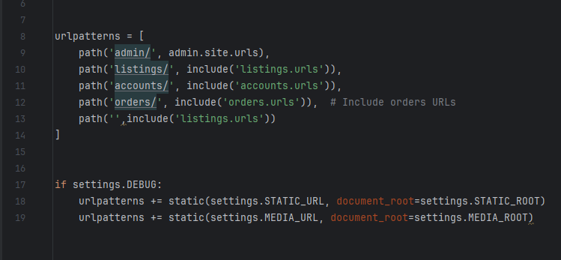

Figure 4. General view of the urls.py

* + **wsgi.py**: Configuration for deploying the project using WSGI.

Figure 5. WSGI.py

* + **Templates Directory**: Contains HTML templates for the website, using Bootstrap for styling.

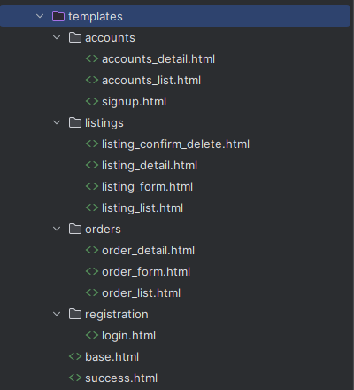

Figure 6. Templates directory

* **Apps**:
  + **Listings (listings)**: Manages property listings.
    - **models.py**: Defines the Listing model.

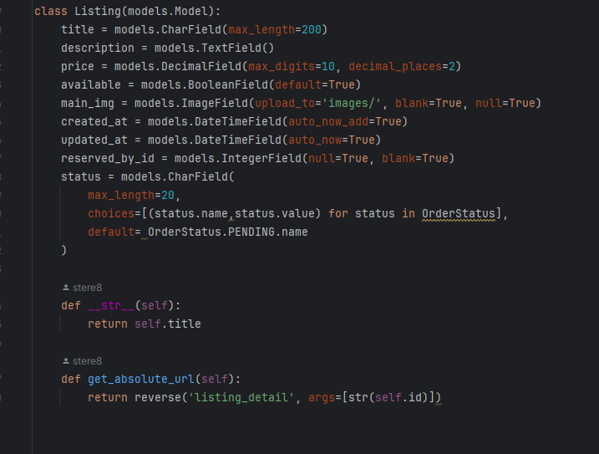

Figure 7. Listings' models.py

* + - **views.py**: Contains views for listing creation, updating, deletion, and reservation.

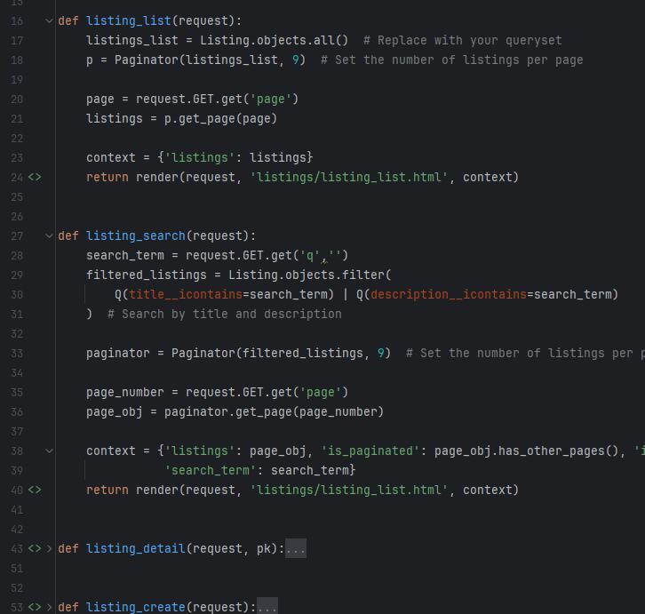

Figure 8. Listings' views.py

* + - **urls.py**: URL patterns for listing-related views.

Figure 9. Listings urls.py

* + - **migrations**: Migration files for the Listing model.

Figure 10. Migrations

* + **Orders (orders)**: Manages orders and reservations.
    - **models.py**: Defines the Order model.

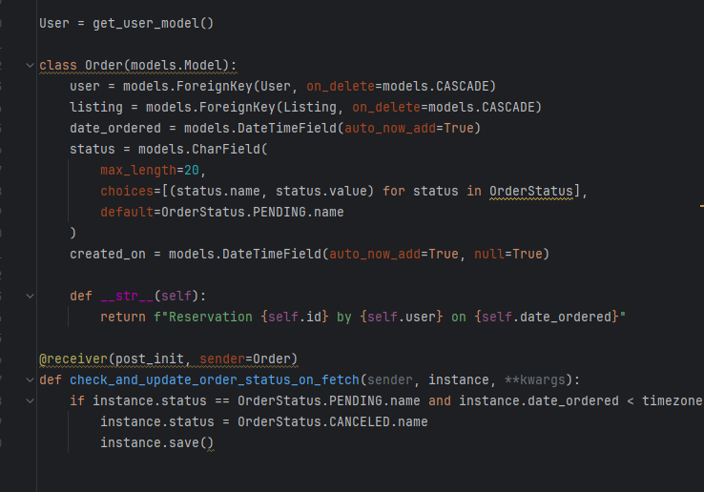

Figure 11. orders' models.py

* + - **views.py**: Contains views for listing and detailing orders.

Figure 12. Orders views.py

* + - **urls.py**: URL patterns for order-related views.

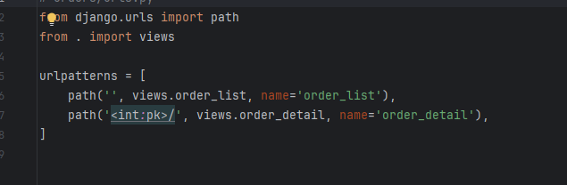

Figure 13. orders urls.py

* + - **migrations**: Migration files for the Order model.

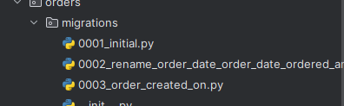

Figure 14. Orders migrations

* + **Accounts (accounts)**: Manages user accounts.
    - **models.py**: Defines a custom user model.

Figure 15. accounts models.py

* + - **views.py**: Contains views for signup, login, logout, and account management.

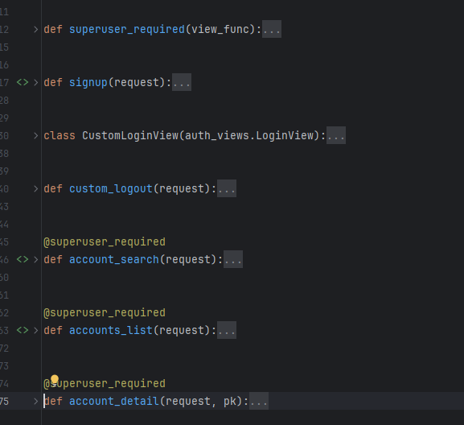

Figure 16. Different views for accounts

* + - **urls.py**: URL patterns for account-related views.

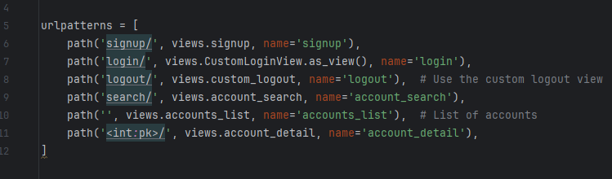

Figure 17. urls for the accounts

* + - **migrations**: Migration files for the User model.

Figure 18. migrations for accounts

**Benefits of App-based Structure**: A well-organized project structure with separate, reusable apps offers several advantages:

* **Maintainability**: Separating functionalities into distinct apps makes the codebase easier to maintain and understand.
* **Scalability**: As the project grows and new features are added, creating new apps promotes modularity and simplifies future development.
* **Reusability**: Individual apps can potentially be reused in other Django projects with similar functionalities.

## 6.2 Key Features and Functionality Development

The development of key features and functionalities is distributed across the different apps:

* **Listings**:
  + **Listing Management**: Users can create, update, delete, and view property listings.

Figure 19. Listing creates

Figure 20Listing deletes

Figure 21. Listing update

* + **Reservation**: Users can reserve listings if available.

Figure 22. Listings reservations

* + **Search**: Users can search for listings by title or description.

Figure 23. Listing search

* **Orders**:
  + **Order Management**: Users can view their orders, and superusers can view all orders.
  + **Order Details**: Users can view detailed information about specific orders.

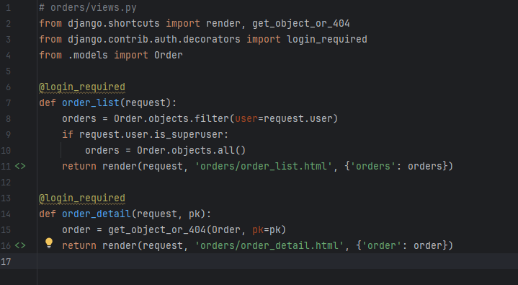

Figure 24. Options on orders

* **Accounts**:
  + **User Registration and Authentication**: Users can sign up, log in, and log out.

Figure 25.User register and login

* + **Account Management**: Users can view and update their account details.

Figure 26. Account view

* + **Account Search**: Superusers can search for user accounts.

Figure 27. Account search

**Additional Functionalities (for future development)**: While the core functionalities are focused on listing management, order management, and user accounts, here are some potential features for future development:

* **User Reviews and Ratings**: Allowing users to leave reviews and ratings for properties and real estate agents can enhance user trust and engagement.
* **Advanced Search Filters**: Implementing advanced search filters based on location, price range, property type, and other criteria can improve the search experience for users.
* **Map Integration**: Integrating a map view for property listings can provide a more visual representation of available properties and their locations.

## 6.3 Integration and Testing

Integration and testing are crucial to ensure the website functions correctly:

* **Integration**:
  + **URL Configuration**: The urls.py files in each app are included in the main urls.py file of the project.
  + **Template Integration**: HTML templates use Django template tags to dynamically generate content and URLs.
* **Testing**:
  + **Unit Tests**: Each app contains a tests.py file for writing unit tests. Although some test files are currently empty, they are placeholders for future tests.
  + **Usability Testing**: Conducting usability testing with real users to identify and address any usability issues.

The manage.py file is essential for running Django commands, such as starting the development server, applying migrations, and running tests.

**Summary**

This chapter outlines the website development process, covering the Django project structure and application design, key features and functionality development, and integration and testing. By following these development principles and utilizing Django's robust framework, the website provides a comprehensive and user-friendly experience for managing real estate listings, orders, and user accounts. The additional functionalities and benefits of an app-based structure further enhance the project's maintainability, scalability, and reusability.

# Chapter 7: Presentation of the Website

## 7.1 Functionality Demonstration

To effectively demonstrate the functionality of the real estate website, you can follow these steps:

1. **User Registration and Login**:
   * **Signup**: Show the user registration process using the signup form. Highlight the validation and error handling.
     + **File Reference**: /accounts/views.py (signup view)

Figure 28. Sign up

* + - **Template**: accounts/signup.html
  + **Login**: Demonstrate the login process and how users are redirected to the listing page upon successful login.
    - **File Reference**: /accounts/views.py (CustomLoginView)

Figure 29. Log in

* + - **Template**: registration/login.html

1. **User Account Management**:
   * **Account Detail**: Show how users can view and update their account details, including reserved listings.
     + **File Reference**: /accounts/views.py (account_detail view)

Figure 30. Account details

* + - **Template**: accounts/accounts_detail.html

1. **Property Listings**:
   * **Listing Creation**: Demonstrate how users can create new property listings using the listing form.
     + **File Reference**: /listings/views.py (listing_create view)

Figure 31. New Listings

* + - **Template**: listings/listing_form.html
  + **Listing Update**: Show the process of updating an existing listing.
    - **File Reference**: /listings/views.py (listing_update view)

Figure 32. Success

Figure 33. Listing details

* + - **Template**: listings/listing_form.html
  + **Listing Deletion**: Demonstrate how users can delete a listing and how the associated image is handled.
    - **File Reference**: /listings/views.py (listing_delete view)

Figure 34. Delete option

* + - **Template**: listings/listing_confirm_delete.html
  + **Listing Search**: Show the search functionality and how users can filter listings based on criteria.
    - **File Reference**: /listings/views.py (listing_search view)

Figure 35. Lisitng search

* + - **Template**: listings/listing_list.html

1. **Order Management**:
   * **Order List**: Demonstrate how users can view their orders and how superusers can view all orders.
     + **File Reference**: /orders/views.py (order_list view)

Figure 36. House reservation

* + - **Template**: orders/order_list.html
  + **Order Detail**: Show the detailed view of a specific order.
    - **File Reference**: /orders/views.py (order_detail view)
    - **Template**: orders/order_detail.html

1. **Reservation System**:
   * **Reserve Listing**: Demonstrate how users can reserve a listing and how an order is created.
     + **File Reference**: /listings/views.py (reserve_listing view)

Figure 37. Reserved listings

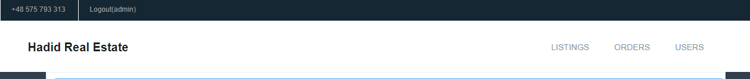

Figure 38. Manage orders option for admin

* + - **Template**: listings/listing_detail.html

## 7.2 Design Showcase

To showcase the design elements of the website, you can highlight the following aspects:

1. **Responsive Design**:
   * **Demonstration**: Show how the website adapts to different screen sizes (desktop, tablet, mobile).

Figure 39. Navbar on a telephone

* + **File Reference**: /real_estate/templates/base.html (Bootstrap integration)
  + **Custom Styles**: /staticfiles/css/mystyle.css

1. **Navigation and Layout**:
   * **Navigation Bar**: Highlight the navigation bar and how it provides easy access to different sections of the website.
     + **File Reference**: /real_estate/templates/base.html

Figure 40. base.html

* + **Page Layouts**: Show the consistent layout across different pages, including the use of containers, rows, and columns.
    - **File Reference**: Various templates in /real_estate/templates

1. **User Interface Elements**:
   * **Forms**: Showcase the design of forms used for user registration, login, listing creation, and account management.
     + **File Reference**: Various templates in /accounts/templates and /listings/templates
   * **Buttons and Alerts**: Highlight the use of buttons and alert messages for user interactions and feedback.
     + **File Reference**: Various templates in /real_estate/templates
2. **Visual Elements**:
   * **Images and Media**: Show how property images are displayed and managed.
     + **File Reference**: /listings/views.py (listing_delete view)
   * **Typography and Icons**: Highlight the use of fonts and icons to enhance the visual appeal of the website.
     + **File Reference**: /real_estate/templates/base.html (Bootstrap and custom styles)

By following this structured approach, we can effectively demonstrate the key functionalities and design elements of the real estate website, providing a comprehensive showcase of the project's capabilities and user experience.

# Chapter 8. Summary and Conclusions

## **8.1 Project Achievements**

The project successfully delivered a comprehensive real estate web application, empowering users and streamlining the property search process. Here's a closer look at the key functionalities:

* **Seamless User Management:**
  + Effortless Registration: Users can create accounts and log in with custom-designed views for a smooth experience.
  + Account Control: Superusers have the power to search, list, and view details of user accounts, ensuring proper management.
  + Enhanced User Experience: A custom user model extends functionalities beyond the default options, providing a more versatile platform.
* **Powerful Listings Management:**
  + Complete Control: Users can create, update, delete, and view real estate listings, offering them complete control over their property presentations.
  + Precise Search and Filtering: The application allows for advanced search and filtering based on various criteria, enabling users to find their perfect property with ease.
  + Reservation at Your Fingertips: A built-in reservation system empowers users to easily reserve listings, creating orders for further processing.
* **Streamlined Order Management:**
  + Order Visibility: Dedicated order list and detail views provide users with clear insights into their reservations. Superusers have the privilege of viewing all orders for comprehensive management.
  + Effortless Admin Integration: Orders are seamlessly integrated into the Django admin interface, making it a breeze for superusers to manage reservations.

## **8.2 Key Learnings and Recommendations**

The project's development process yielded valuable insights and established best practices for future enhancements:

* **Modular Design for Maintainability:** The project's well-structured architecture with separate apps promotes modularity and simplifies future maintenance efforts.
* **Enhanced User Experience:** Utilizing Bootstrap for styling has resulted in a more intuitive and responsive user interface, making navigation a breeze.
* **Security at the Forefront:** Secure password handling and user authentication practices ensure the application upholds robust security standards.
* **Best Practices in Action:** Adherence to Django's best practices regarding settings separation (development and production configurations) has been instrumental in project development.

**8.3 Future Considerations and Enhancements**

This project serves as a solid foundation, and future endeavors will focus on further improvements to provide even greater value:

* **Granular User Roles and Permissions:** Introducing more defined user roles (agents, buyers) along with specific permissions will enhance the platform's ability to cater to different user profiles.
* **Advanced Search Refinements:** Implementing more advanced search filters and sorting options will empower users with even greater precision in their property searches.
* **Real-Time Notifications:** Building a notification system will keep users informed about crucial events (new listings, reservation confirmations), promoting a more interactive experience.
* **Mobile App Expansion:** Developing a mobile application will provide users with on-the-go access and greater flexibility in navigating the platform.
* **Data-Driven Insights:** Creating an analytics dashboard will equip superusers with valuable data about user activity, listing performance, and other key metrics, allowing for informed decision-making.

By focusing on these advancements, the real estate web application will continue to evolve, offering unmatched value to all its users.

# Glossary

| **Term** | **Definition** |
| --- | --- |
| **Accessibility** | Ensuring that websites and applications can be used by as many people as possible, including those with disabilities. Techniques include using semantic HTML, ARIA attributes, and keyboard navigation. |
| **Accounts App** | A component of the Django project responsible for managing user accounts, including signup, login, logout, and account management. |
| **App-based Structure** | An organizational method in Django projects where functionalities are divided into separate, reusable apps. This enhances maintainability, scalability, and reusability. |
| **ARIA (Accessible Rich Internet Applications)** | Attributes added to HTML elements to improve accessibility for users with screen readers by providing additional information about UI elements' roles and states. |
| **Bootstrap** | A popular front-end framework used for developing responsive and mobile-first websites. |
| **Django** | A high-level Python web framework that encourages rapid development and clean, pragmatic design. |
| **Framework** | A set of tools and libraries that provide a structure to develop applications, promoting code reuse and modularity. |
| **Integration** | The process of combining various components of a software project to function together as a whole. Involves configuring URL patterns and integrating templates. |
| **Listings App** | A component of the Django project responsible for managing property listings, including creation, updating, deletion, and reservation. |
| **Models** | In Django, models define the structure of the database and represent the entities and their relationships. They are defined in a file named models.py. |
| **Orders App** | A component of the Django project responsible for managing orders and reservations related to property tours and purchases. |
| **Project Directory** | The main directory of a Django project, containing configuration files like settings.py, urls.py, and wsgi.py. |
| **Responsive Design** | Designing websites to provide an optimal viewing experience across a wide range of devices, from mobile phones to desktop computers. |
| **Scalability** | The ability of a project to handle growth, such as an increase in users or data volume, by efficiently adding resources. |
| **Semantic HTML** | HTML that uses elements meaningfully to describe the structure of the content, such as <header>, <nav>, <main>, and <footer>. |
| **Settings.py** | A configuration file in a Django project that sets up the database, installed apps, middleware, and static and media file locations. |
| **Templates Directory** | A directory in a Django project containing HTML templates that use Django template tags to dynamically generate content and URLs. |
| **URL Patterns** | In Django, URL patterns map URLs to views. They are defined in urls.py files. |
| **Usability Testing** | A process where real users interact with a website or application to identify usability issues and improve user experience. |
| **User Interface (UI)** | The design and layout of the interactive elements of a website or application, focusing on the look and feel. |
| **User Flow** | The path taken by a user through a website or application to complete a task, designed to ensure ease of use and efficiency. |
| **Views** | In Django, views handle the logic for displaying data to the user. They retrieve data from models, apply business logic, and render templates. |

# References

1. **Django Documentation**:
   * **Title**: Django Documentation
   * **Link**: https://docs.djangoproject.com/en/5.0/
2. **Bootstrap Documentation**:
   * **Title**: Bootstrap Documentation
   * **Link**: https://getbootstrap.com/docs/5.3/getting-started/introduction/
3. **SQLite Documentation**:
   * **Title**: SQLite Documentation
   * **Link**: https://www.sqlite.org/docs.html
4. **Pillow (PIL Fork) Documentation**:
   * **Title**: Pillow (PIL Fork) Documentation
   * **Link**: https://www.sqlite.org/docs.html
5. **Figma Documentation**:
   * **Title**: Figma Documentation
   * **Link**: <https://help.figma.com/hc/en-us>
6. Ovid Real Estate:
   * **Link**: https://ovid-realestates.com/
7. Redfin
   * **Link**: https://ayatrealestate.com/
8. Ayat Real Estate:
   * **Link**: https://www.redfin.com/